Nama : Rai Tilosava De Araujo  
Kelas : IF21B  
NIM : 21416255201184  
ADBO Praktek – Tugas Pertemuan 11 – Sequence Diagram

Rute Pencarian – Sequence Diagram

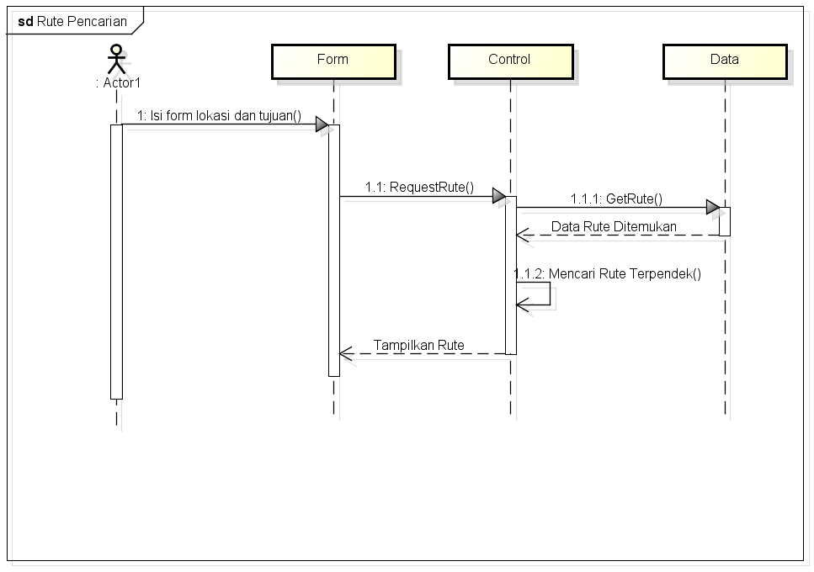

Sistem Apotek – Sequence Diagram

